Dear StrongStart Families,

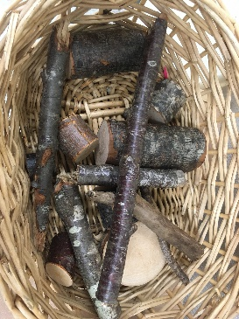
We hope everyone is doing well and staying safe. It has been wonderful to reconnect with you after so much time apart, and to meet many new faces. To those families who have not been able to make it to StrongStart or our outdoor program, we hope to see you in the new year!
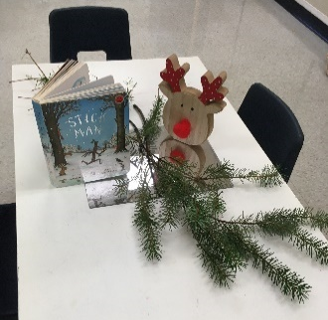
If you have been to our classrooms, you have likely noticed our focus on more natural materials (wood pieces, stones, chestnuts, sticks) or recycled items (cardboard tubes, tin cans). By offering these, we encourage children to use their imagination and creativity. These open-ended materials also provide a different sensory experience than typical plastic toys and since they are usually found right outside, your child can collect their own basket of treasure to play with at home. As the seasons change, it has been exciting for the children to see what new materials nature has to offer!
As 2020 comes to an end, we want to quickly reflect on some of the challenges we have faced and the difficult tasks that were asked of us – such as staying apart from our friends and loved ones. With holidays and winter break coming up, we recognize that not everyone will be able to celebrate or spend the time as they had planned. We have put together some ideas that can be done with your little ones (most without even leaving your home)! These simple activities may be part of your family tradition already, or things you do each year, but you may find something new or get an idea for something better. This holiday season may be a bit more slow-paced so it might be the right time to pull out that big puzzle or perfect that blanket fort you’re always being asked to make. Whatever the next few weeks bring, we hope that you find the joy in the little things and stay safe.
Over the break StrongStart may be closed, but our early years Family Navigator will still be available to offer support. If you need help finding or accessing resources, or need someone to talk to, please contact Brianne at 604-219-3311 or brianne.huish@mpsd.ca.
Wishing you all a wonderful winter break and we look forward to seeing you in the new year!
From your Early Years team,
Alison, Brianne, Diana, Julie and Jun

Gingerbread Cookies
Ingredients
1/2 cup butter, softened
3/4 cup packed brown sugar
1/3 cup molasses
1 large egg, room temperature
2 tbsp water
2-2/3 cups all-purpose flour
1 tsp baking soda
1/2 tsp salt
2 tsp ground ginger
1/2 tsp ground cinnamon
1/2 tsp ground nutmeg
1/2 tsp ground allspice
(frosting of your choice)

Directions

- Cream butter and brown sugar until light and fluffy. Beat in molasses, egg and water. In another bowl, whisk together remaining ingredients minus frosting; gradually beat into creamed mixture. Divide dough in half. Shape each into a dish; cover. Refrigerate until easy to handle, about 30 minutes.

- Preheat oven to 350 degrees. On a lightly floured surface, roll each portion of dough to 1/8 inch thickness. Cut with a floured 4-inch gingerbread man cookie cutter (or any shape you have). Place 2 inches apart on greased baking sheets.

- Bake until edges are firm, 8-10 minutes. Remove to wire rack to cool completely. Frost as desired.

(Recipe from https://www.tasteofhome.com/recipes/gingerbread-men-cookies/)

Check out Miss Diana’s YouTube video and watch her tell “The Gingerbread Man” story!
https://youtu.be/JGCjbMRgevU

